**Project Details**

* All the projects are Computer Vision Related.

Every Group has been assigned a kaggle link.  
Explore the dataset, each team will have to tag their images using Labelme.

Then each team will be training their Detectron2 instance segmentation models.

**Target** --

- Use at least 400 training images

- Get an overall AP (Average Precision) metric above 85.

- Create a Streamlit UI and a Flask app around your implementation.

**Submission --**

* Submit a git repo.
* Readme should have the overall train/val/test metrics, UI images, examples, and basic overview.

**Datasets --**

* Face Mask - <https://www.kaggle.com/datasets/aditya276/face-mask-dataset-yolo-format>
* Wind Turbine - <https://www.kaggle.com/datasets/ajifoster3/yolo-annotated-wind-turbines-586x371/data>
* Traffic Signs - <https://www.kaggle.com/datasets/valentynsichkar/traffic-signs-dataset-in-yolo-format>
* Drug Name - <https://www.kaggle.com/datasets/pkdarabi/the-drug-name-detection-dataset>
* Pothole - <https://www.kaggle.com/code/harpdeci/yolo-nas-pothole-detection/input>

**Workflow --**

* **Tag images using Labelme**
* **Few teams have the same project, they can communicate on data tagging part. But train individual models.**
* **Convert the tagged data into COCO format as needed by detectron2 models.**
* **Train Instance segmentation model of your choice.**
* **Create the API and UI**
* **Create the** **Git repo.**

**References --**

* <https://github.com/facebookresearch/detectron2>
* <https://youtu.be/Pb3opEFP94U?feature=shared>
* [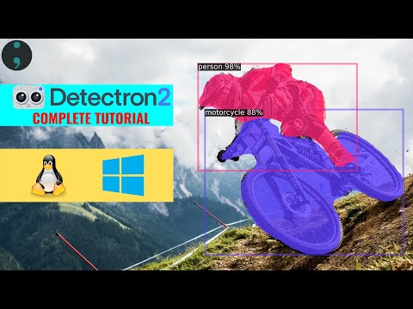](https://youtu.be/Pb3opEFP94U?feature=shared)
* <https://pypi.org/project/labelme/>
* <https://youtu.be/eUSgtfK4ivk?feature=shared>
* <https://youtu.be/GoItxr16ae8?feature=shared>

**Notes --**

* Use Google Colab or Kaggle for model training. Don’t do training locally.
* Collaborate with other teams for training data and general issues.